/*================================================================================
PROJECT: Console - Based Quiz Game
AUTHORS : [Subhan,Asad,Hamza]
VERSION : 1.2
DATE : 09 / 12 / 2025

DESCRIPTION:
An interactive quiz game featuring :
-5 Categories(Science, Computer, Sports, History, IQ)
- 3 Difficulty Levels
- Real - time countdown timer without blocking input
- Lifelines(50 / 50, Skip, Replace, Extra Time)
- Persistent High Score and Log tracking
- Input validation to prevent crashes

NOTE :
-Uses <conio.h> for _kbhit() (keyboard hit detection).
- Uses <thread> and <chrono> for accurate timing and sleeping.
================================================================================
*/

#include <iostream>
#include <cstdlib> // For rand() and srand()
#include <fstream> // For file handling (txt files)
#include <string> // For string manipulation
#include <ctime> // For time()
#include <algorithm> // For swap()
#include <chrono> // For high-resolution timer
#include <thread> // For this_thread::sleep_for()
#include <conio.h> // For _kbhit() and _getch() (Windows specific)

using namespace std;

// ======================= CONFIGURATION =======================
const int TOTAL_QUESTIONS = 150; // Max capacity for loading questions
const int SESSION_QUESTIONS = 10; // How many questions per game

// ======================= GLOBAL VARIABLES =======================

// --- File & Question Data ---
string filename; // Current category filename
string questions[TOTAL_QUESTIONS]; // Buffer to hold loaded lines from file
int indices[50]; // Indices available for current difficulty
int used_indices[50]; // Track used questions to prevent repeats
int used_count = 0; // How many questions used so far

// --- Game State ---
int score = 0; // Current player score
int category = 0; // User selected category (1-5)
int difficulty = 0; // User selected difficulty (1-3)
string playername; // Player name for logging
int streak = 0; // Consecutive correct answers
int timer = 15; // Seconds allowed per question
bool replace_requested = false; // Flag to trigger question replacement

// --- Lifeline Status (True = Available, False = Used) ---
bool lifeline_5050 = true;
bool lifeline_skip = true;
bool lifeline_replace = true;
bool lifeline_extratime = true;

// --- Review System Data ---
// Stores details of wrong answers to show at the end
string incorrect_questions[SESSION_QUESTIONS];
string incorrect_options[SESSION_QUESTIONS][4];
int incorrect_correct_pos[SESSION_QUESTIONS];
int incorrect_count = 0; // Total wrong answers
int correct_count = 0; // Total correct answers
int wrong_count = 0; // Total wrong answers (same as above, distinct counter)

// ======================= FUNCTION PROTOTYPES =======================
string cut(string & s);
void shuffle_array(int arr[], int n);
int load_questions(string filename);
void display_question(string question, string options[], int correct_pos, int q_num, bool is_review);
void start_quiz();
void save_high_score(string player, int score, string category, string difficulty);
void show_high_scores();
bool get_answer_with_timer(int& answer, int time_limit);
void display_timer_bar(int remaining);
void use_lifeline_5050(string options[], int correct_pos);
void use_lifeline_skip();
bool use_lifeline_replace(int& current_index, int used_indices[], int& used_count);
void use_lifeline_extratime(int& timer_ref);
void reset_lifelines();
string get_current_datetime();
void save_quiz_log(string player, string category_str, string difficulty_str, int correct, int wrong, int total_score);
void review_incorrect_questions();
void post_quiz_menu();

// ======================= MAIN EXECUTION =======================

int main() {

srand(time(0)); // Seed random number generator with current time

while (true) {
// --- Main Menu Display ---
system("cls");
cout << "========================================\n";
cout << " CONSOLE-BASED QUIZ GAME\n";
cout << "========================================\n";
cout << "1. Start New Quiz\n";
cout << "2. View High Scores\n";
cout << "3. Exit\n";
cout << "Enter choice: ";

int choice;
// INPUT VALIDATION: Prevents crash if user enters text (e.g., 'a')
if (!(cin >> choice)) {
cout << "\nInvalid Input! Please enter a number.\n";
cin.clear(); // Clear error flag
cin.ignore();// Discard bad input
system("pause");
continue; // Restart loop
}
cin.ignore(); // Clear newline character from buffer

if (choice == 3) break; // Exit application

switch (choice) {
case 1:
{
// --- New Game Setup ---
system("cls");
cout << "Enter your name: ";
getline(cin, playername);

// Category Selection with Validation Loop
while (true) {
cout << "\n=== SELECT CATEGORY ===\n";
cout << "1. Science\n2. Computer\n3. Sports\n4. History\n5. IQ/Logic\n";
cout << "Enter choice: ";
if (cin >> category && category >= 1 && category <= 5) {
cin.ignore(10000, '\n');
break;
}
cout << "Invalid category! Try again.\n";
cin.clear();
cin.ignore();
}

// Difficulty Selection with Validation Loop
while (true) {
cout << "\n=== SELECT DIFFICULTY ===\n";
cout << "1. Easy\n2. Medium\n3. Hard\n";
cout << "Enter choice: ";
if (cin >> difficulty && difficulty >= 1 && difficulty <= 3) {
cin.ignore();
break;
}
cout << "Invalid difficulty! Try again.\n";
cin.clear();
cin.ignore();
}

// Reset all game state variables before starting
streak = 0;
timer = 15;
incorrect_count = 0;
correct_count = 0;
wrong_count = 0;
reset_lifelines();

// Begin the quiz
start_quiz();
break;
}
case 2:
system("cls");
show_high_scores();
break;
default:
cout << "Invalid choice.\n";
system("pause");
}
}

cout << "\nThank you for playing!\n";
return 0;
}

// ======================= UTILITY FUNCTIONS =======================

/*
* Function: cut
* Purpose: Splits a string based on the '|' delimiter.
* Mechanism: Finds the first '|', returns the substring before it,
* and modifies the original string to remove that part.
*/
string cut(string & s) {
int pos = s.find('|');
if (pos == string::npos) {
string result = s;
s = ""; // String is empty now
return result;
}
string part = s.substr(0, pos);
s = s.substr(pos + 1); // Update original string
return part;
}

/*
* Function: shuffle_array
* Purpose: Randomizes an integer array using Fisher-Yates algorithm.
* Used For: Randomizing question order and option order.
*/
void shuffle_array(int arr[], int n) {
for (int i = n - 1; i > 0; i--) {
int j = rand() % (i + 1);
int temp = arr[i];
arr[i] = arr[j];
arr[j] = temp;
}
}

/*
* Function: load_questions
* Purpose: Reads the specific text file into the 'questions' array.
*/
int load_questions(string filename) {
ifstream fin(filename);
if (!fin.is_open()) return 0; // File error

int count = 0;
while (getline(fin, questions[count]) && count < TOTAL_QUESTIONS) {
count++;
}
fin.close();
return count; // Returns number of questions loaded
}

/*
* Function: get_current_datetime
* Purpose: Returns current system time formatted as "YYYY-MM-DD HH:MM:SS"
* Used for logging.
*/
string get_current_datetime() {
time_t now = time(0);
tm t;
localtime_s(&t, &now);
char buffer[50];
sprintf_s(buffer, "%04d-%02d-%02d %02d:%02d:%02d",
1900 + t.tm_year, 1 + t.tm_mon, t.tm_mday, t.tm_hour, t.tm_min, t.tm_sec);
return string(buffer);
}

// ======================= TIMER & INPUT LOGIC =======================

/*
* Function: display_timer_bar
* Purpose: Updates the timer text on the same line using '\r' (Carriage Return).
* Note: '\r' moves the cursor to the start of the line, allowing overwrite.
*/
void display_timer_bar(int remaining) {
cout << "\r[ TIME LEFT: " << remaining << "s ] Your answer (1-4) or Lifeline (5-8): ";
cout.flush(); // Forces the text to appear immediately
}

/*
* Function: get_answer_with_timer
* Purpose: The core non-blocking input loop.
* Logic:
* 1. Records start time.
* 2. Enters a loop that checks time elapsed.
* 3. Uses _kbhit() to check if keyboard key is pressed WITHOUT pausing execution.
* 4. If key pressed -> Read input.
* 5. If time out -> Return false.
*/
bool get_answer_with_timer(int& answer, int time_limit) {
auto start_time = chrono::steady_clock::now();
bool input_received = false;

// Show initial timer
display_timer_bar(time_limit);

while (!input_received) {
// Calculate remaining time
auto current_time = chrono::steady_clock::now();
auto elapsed = chrono::duration_cast<chrono::seconds>(current_time - start_time).count();
int remaining = time_limit - (int)elapsed;

// Update display if time is left
if (remaining >= 0) {
display_timer_bar(remaining);
}

// Check if Time is Up
if (elapsed >= time_limit) {
cout << "\n\nTime's up!\n";
while (_kbhit()) _getch(); // Clear any accidental keystrokes buffered during timeout
return false;
}

// Check for Input (Non-blocking)
if (_kbhit()) {
// Attempt to read integer
if (cin >> answer) {
cin.ignore(10000, '\n');
return true; // Valid input received
}
else {
// User typed a letter, clear error and let them try again
cin.clear();
cin.ignore(10000, '\n');
}
}

// Small sleep to reduce CPU usage
this_thread::sleep_for(chrono::milliseconds(100));
}
return false;
}

// ======================= LIFELINE LOGIC =======================

void reset_lifelines() {
lifeline_5050 = true;
lifeline_skip = true;
lifeline_replace = true;
lifeline_extratime = true;
}

// Removes 2 incorrect options from the display array
void use_lifeline_5050(string options[], int correct_pos) {
if (!lifeline_5050) {
cout << "\n[!] 50/50 already used!\n";
return;
}
lifeline_5050 = false;
cout << "\n[LIFELINE] 50/50 Used. Removing 2 options...\n\n";

int removed = 0;
// Iterate and remove first 2 options that are NOT the correct one
for (int i = 0; i < 4 && removed < 2; ++i) {
if (i != correct_pos) {
options[i] = "[REMOVED]";
removed++;
}
}
}

// Just sets the flag; actual logic happens in display_question (it returns)
void use_lifeline_skip() {
if (!lifeline_skip) {
cout << "\n[!] Skip already used!\n";
return;
}
lifeline_skip = false;
cout << "\n[LIFELINE] Question Skipped!\n";
}

// Finds a new question index that hasn't been used yet
bool use_lifeline_replace(int& current_index, int used_indices[], int& used_count) {
if (!lifeline_replace) {
cout << "\n[!] Replace already used!\n";
return false;
}
lifeline_replace = false;
cout << "\n[LIFELINE] Replace Question Used. Finding new question...\n";

int start_index = (difficulty - 1) * 50;

// Linear search for an unused question index
for (int i = start_index; i < start_index + 50; i++) {
bool is_used = false;
for (int j = 0; j < used_count; j++) {
if (used_indices[j] == i) {
is_used = true;
break;
}
}
if (!is_used) {
current_index = i; // Update current index
used_indices[used_count++] = i; // Mark new one as used
return true;
}
}
return false;
}

// Adds 10 seconds to the reference timer variable
void use_lifeline_extratime(int& timer_ref) {
if (!lifeline_extratime) {
cout << "\nExtra Time already used!\n";
return;
}
lifeline_extratime = false;
timer_ref += 10;
cout << "\n[LIFELINE] +10 Seconds Added!\n";
}

// ======================= DATA PERSISTENCE =======================

// Appends detailed logs to quiz_logs.txt
void save_quiz_log(string player, string category_str, string difficulty_str, int correct, int wrong, int total_score) {
ofstream fout("quiz_logs.txt", ios::app);
if (!fout.is_open()) {
cout << "Error opening quiz_logs.txt\n";
return;
}
fout << "========================================\n";
fout << "Player: " << player << "\n";
fout << "Date and Time: " << __DATE__ <<" " << __TIME__ << "\n";
fout << "Category: " << category_str << "\n";
fout << "Difficulty: " << difficulty_str << "\n";
fout << "Correct: " << correct << " | Wrong: " << wrong << "\n";
fout << "Score: " << total_score << "/" << SESSION_QUESTIONS << "\n";
fout << "========================================\n\n";
fout.close();
}

// Appends high score to high_scores.txt (Pipe delimited)
void save_high_score(string player, int score, string category, string difficulty) {
ofstream fout("high_scores.txt", ios::app);
if (!fout.is_open()) return;
fout << player << "|" << score << "|" << category << "|" << difficulty << "\n";
fout.close();
}

// Reads, parses, sorts, and displays high scores
void show_high_scores() {
const int maxentries = 100;
string player[maxentries];
int score[maxentries];
string category[maxentries];
string difficulty[maxentries];
int count = 0;

ifstream fin("high_scores.txt");
if (!fin.is_open()) {
cout << "No high scores found!\nPress Enter...";
cin.get();
return;
}

// Parse file line by line
string line;
while (getline(fin, line) && count < maxentries) {
string temp = line;
player[count] = cut(temp);
score[count] = stoi(cut(temp));
category[count] = cut(temp);
difficulty[count] = cut(temp);
count++;
}
fin.close();

// Bubble Sort (Descending Order by Score)
for (int i = 0; i < count - 1; i++) {
for (int j = 0; j < count - i - 1; j++) {
if (score[j] < score[j + 1]) {
swap(score[j], score[j + 1]);
swap(player[j], player[j + 1]);
swap(category[j], category[j + 1]);
swap(difficulty[j], difficulty[j + 1]);
}
}
}

cout << "========================================\n";
cout << " HIGH SCORES\n";
cout << "========================================\n\n";
cout << "Player\tScore\tCategory\tDifficulty\n";
for (int i = 0; i < count; i++) {
cout << player[i] << "\t" << score[i] << "\t" << category[i] << "\t\t" << difficulty[i] << "\n";
}
cout << "\nPress Enter to return...";
cin.ignore();
cin.get();
}

// ======================= GAME LOGIC =======================

// Displays incorrect questions stored during the session
void review_incorrect_questions() {
if (incorrect_count == 0) {
cout << "\nGreat job! No incorrect answers.\nPress Enter...";
cin.get();
return;
}

system("cls");
cout << "REVIEWING INCORRECT ANSWERS\n";
cout << "Press Enter to start...";
cin.get();

for (int i = 0; i < incorrect_count; i++) {
system("cls");
cout << "Review Q" << i + 1 << "\n\n";
// Calls display_question in 'review mode' (is_review = true)
display_question(incorrect_questions[i], incorrect_options[i], incorrect_correct_pos[i], 0, true);
}
cout << "\nReview complete! Press Enter...";
cin.get();
}

// Handles end-of-game options
void post_quiz_menu() {
while (true) {
system("cls");
cout << "========================================\n";
cout << " QUIZ COMPLETE!\n";
cout << "========================================\n";
cout << "Score: " << score << "\n";
cout << "Correct: " << correct_count << " | Wrong: " << wrong_count << "\n\n";
cout << "1. Review Incorrect Questions\n";
cout << "2. Replay Quiz\n";
cout << "3. Main Menu\n";
cout << "Enter choice: ";

int choice;
// Validation check
if (!(cin >> choice)) {
cout << "Invalid Input.\n";
cin.clear();
cin.ignore(10000, '\n');
system("pause");
continue;
}
cin.ignore(10000, '\n');

if (choice == 1) {
review_incorrect_questions();
}
else if (choice == 2) {
// Reset variables for replay
streak = 0;
timer = 15;
incorrect_count = 0;
correct_count = 0;
wrong_count = 0;
reset_lifelines();
start_quiz();
return;
}
else if (choice == 3) {
return;
}
}
}

/*
* Function: display_question
* Purpose: Displays the question, handles option shuffling, inputs, and scoring.
* Logic:
* 1. Shuffles options so Answer A isn't always the correct one.
* 2. Displays question text and shuffled options.
* 3. Calls get_answer_with_timer() to wait for input.
* 4. Processes correct answer, wrong answer, or lifeline usage.
*/
void display_question(string question, string options[], int correct_pos, int q_num, bool is_review = false) {
int map[4] = { 0,1,2,3 }; // Maps shuffled positions to original positions
int current_timer = timer;

// Copy original options to a temp array for shuffling
string shuffled_options[4];
for (int i = 0; i < 4; i++) shuffled_options[i] = options[i];

// Shuffle Logic (Only if not in review mode)
if (!is_review) {
for (int i = 3; i > 0; i--) {
int j = rand() % (i + 1);
swap(shuffled_options[i], shuffled_options[j]);
swap(map[i], map[j]);
}
}
else {
// In review mode, keep original order or simple order
for (int i = 0; i < 4; i++) map[i] = i;
}

// Determine where the correct answer moved to
int new_correct = 0;
for (int i = 0; i < 4; i++) {
if (map[i] == correct_pos) new_correct = i;
}

// Display Text
cout << question << "\n\n";
for (int i = 0; i < 4; i++) cout << i + 1 << ") " << shuffled_options[i] << "\n";

// --- Review Mode Exit ---
if (is_review) {
cout << "\n** Correct Answer: " << shuffled_options[new_correct] << " **\n";
cout << "Press Enter...";
cin.get();
return;
}

// --- Active Game Mode ---
cout << "\n--- Lifelines ---\n";
cout << "5) 50/50" << (lifeline_5050 ? " [OK]" : " [USED]") << " ";
cout << "6) Skip" << (lifeline_skip ? " [OK]" : " [USED]") << "\n";
cout << "7) Replace" << (lifeline_replace ? " [OK]" : " [USED]") << " ";
cout << "8) +Time" << (lifeline_extratime ? " [OK]" : " [USED]") << "\n\n";

int answer;
// Call the timer function to get input
bool answered_in_time = get_answer_with_timer(answer, current_timer);

// Calculate penalty based on difficulty
int negativemark = (difficulty == 1) ? 2 : (difficulty == 2) ? 3 : 5;

// --- TIMEOUT HANDLER ---
if (!answered_in_time) {
cout << "Time's up! Correct: " << shuffled_options[new_correct] << "\n";
score -= negativemark;
streak = 0;
wrong_count++;
// Save for review
incorrect_questions[incorrect_count] = question;
for (int i = 0; i < 4; i++) incorrect_options[incorrect_count][i] = shuffled_options[i];
incorrect_correct_pos[incorrect_count] = new_correct;
incorrect_count++;
cout << "Score: " << score << "\nPress Enter...";
cin.ignore(); cin.get();
return;
}

// --- LIFELINE HANDLERS ---
if (answer == 5) {
use_lifeline_5050(shuffled_options, new_correct);
cout << "Options updated:\n";
for (int i = 0; i < 4; i++) cout << i + 1 << ") " << shuffled_options[i] << "\n";

// Ask again with remaining time
answered_in_time = get_answer_with_timer(answer, current_timer);
if (!answered_in_time) {
// Handle timeout after using lifeline
score -= negativemark;
wrong_count++;
incorrect_questions[incorrect_count] = question;
for (int i = 0; i < 4; i++) incorrect_options[incorrect_count][i] = shuffled_options[i];
incorrect_correct_pos[incorrect_count] = new_correct;
incorrect_count++;
cout << "Time's up! Score: " << score << "\nPress Enter...";
cin.ignore(); cin.get();
return;
}
}
else if (answer == 6) {
use_lifeline_skip();
cout << "Press Enter...";
cin.ignore(); cin.get();
return;
}
else if (answer == 7) {
if (lifeline_replace) {
use_lifeline_replace(indices[q_num], used_indices, used_count);
replace_requested = true; // Signals start_quiz loop to restart this iteration
}
cout << "Press Enter...";
cin.ignore(); cin.get();
return;
}
else if (answer == 8) {
use_lifeline_extratime(current_timer);
// Ask again with new time
answered_in_time = get_answer_with_timer(answer, current_timer);
if (!answered_in_time) {
score -= negativemark;
wrong_count++;
incorrect_questions[incorrect_count] = question;
for (int i = 0; i < 4; i++) incorrect_options[incorrect_count][i] = shuffled_options[i];
incorrect_correct_pos[incorrect_count] = new_correct;
incorrect_count++;
cout << "Time's up! Score: " << score << "\nPress Enter...";
cin.ignore(); cin.get();
return;
}
}

// --- SCORE CALCULATION ---
answer--; // Convert input (1-4) to 0-based index (0-3)

if (answer == new_correct) {
cout << "\nCorrect!\n";
score++;
streak++;
correct_count++;
// Bonus points logic
if (streak == 3) { score += 5; cout << "Streak Bonus +5!\n"; }
if (streak == 5) { score += 15; cout << "Streak Bonus +15!\n"; streak = 0; }
}
else {
cout << "\nWrong! Correct: " << shuffled_options[new_correct] << "\n";
score -= negativemark;
cout << "Penalty: -" << negativemark << "\n";
streak = 0;
wrong_count++;

// Save for review
incorrect_questions[incorrect_count] = question;
for (int i = 0; i < 4; i++) incorrect_options[incorrect_count][i] = shuffled_options[i];
incorrect_correct_pos[incorrect_count] = new_correct;
incorrect_count++;
}

cout << "Score: " << score << "\nPress Enter...";
cin.ignore(); cin.get();
}

/*
* Function: start_quiz
* Purpose: Main game loop. Loads questions and iterates through them.
*/
void start_quiz() {
// Select File
switch (category) {
case 1: filename = "science.txt"; break;
case 2: filename = "computer.txt"; break;
case 3: filename = "sports.txt"; break;
case 4: filename = "history.txt"; break;
case 5: filename = "iq.txt"; break;
}

if (load_questions(filename) == 0) {
cout << "Failed to load questions. Check file existence.\nPress Enter...";
cin.get();
return;
}

// Prepare Indices (Difficulty Logic)
used_count = 0;
int startindex = (difficulty - 1) * 50; // Easy=0, Medium=50, Hard=100
for (int i = 0; i < 50; i++) indices[i] = startindex + i;
shuffle_array(indices, 50);
score = 0;

// Loop through 10 questions
for (int q = 0; q < SESSION_QUESTIONS; ) {
system("cls");
string line = questions[indices[q]];

// Parse the line (Question|Opt1|Opt2|Opt3|Opt4|CorrectIdx)
string question = cut(line);
string a = cut(line), b = cut(line), c = cut(line), d = cut(line);
string correct_str = cut(line);

// Validation against empty lines
if (correct_str.empty() || question.empty()) {
q++; continue;
}

string options[4] = { a, b, c, d };
cout << "Question " << q + 1 << " of " << SESSION_QUESTIONS << "\n\n";

// Show Question
display_question(question, options, stoi(correct_str) - 1, q, false);

// Handle 'Replace Question' Lifeline
if (replace_requested) {
replace_requested = false;
continue; // Skip the increment of 'q' to retry this slot
}

// Mark question as used and move to next
used_indices[used_count++] = indices[q];
q++;
}

// Prepare strings for logging
string cat_str = (category == 1 ? "Science" : category == 2 ? "Computer" :
category == 3 ? "Sports" : category == 4 ? "History" : "IQ");
string diff_str = (difficulty == 1 ? "Easy" : difficulty == 2 ? "Medium" : "Hard");

// Save Data
save_quiz_log(playername, cat_str, diff_str, correct_count, wrong_count, score);
save_high_score(playername, score, cat_str, diff_str);

// Show End Menu
post_quiz_menu();
}
MENU
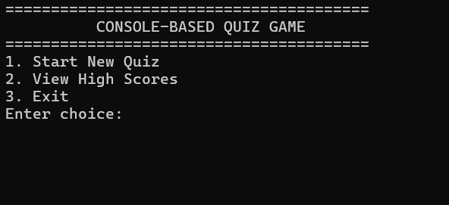
GAMEPLAY
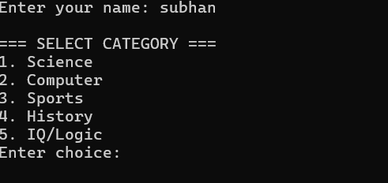
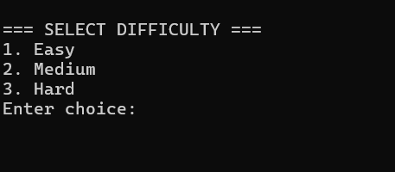
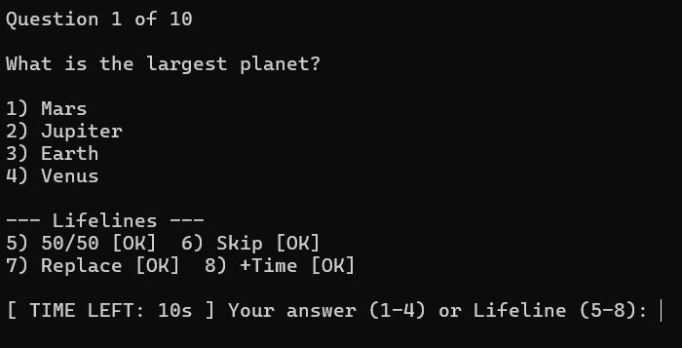
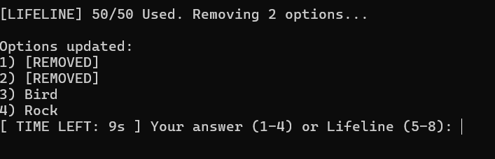
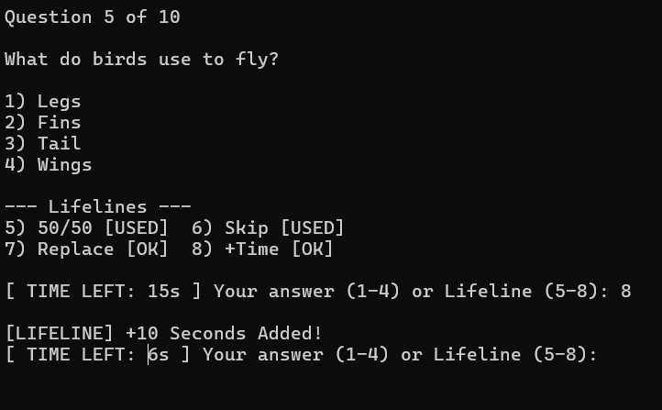
Score Board
